**HOTEL BOOKING MANAGEMENT**

END TERM REPORT

***by***

(Section: K19RH)

**AKHIL S NAIR**

(Roll no-10)

**SREEHARI S**

(Roll no-13)

**YUVRAJ SINGH YADAV**

(Roll no-22)



**Department of Intelligent Systems**

**School of Computer Science Engineering**

**Lovely Professional University, Jalandhar**

**APRIL -2020**

**Acknowledgment**

I would like to express my special thanks of gratitude to my CSE teacher “Miss Shabnam” for their able guidance and support in completing my project.

I would like to extend my gratitude to CSE department for proving me with all the facility that was required.

DATE:

10 -04-2020

**Student Declaration**

This is to declare that this report has been written by us. No part of the report is copied from other sources. All information included from other sources have been duly acknowledged. We aver that if any part of the report is found to be copied, we are shall take full responsibility for it.



(AKHIL S NAIR-10)



(SREEHARI S-13)

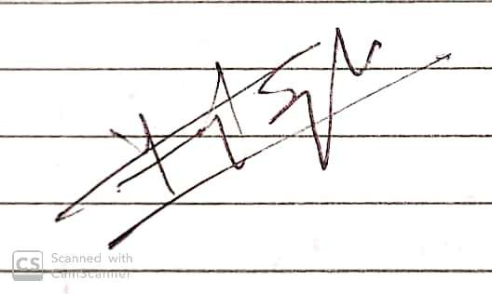

(YUVRAJ SINGH YADAV-22)

BONAFIDE CERTIFICATE

Certified that this project report “………. HOTEL BOOKING MANAGEMANT…………….” is the bonafide work of “……AKHIL S NAIR……SREEHARI S..……YUVRAJ SINGH YADAV……” who carried out the project work under my supervision.

Signature of the Supervisor

Name of supervisor

Academic Designation

ID of Supervisor

Department of Supervisor

**TABLE OF CONTENTS**

**TITLE**

**1. Acknowledgement**

**2. Introduction**

**3. Advantages and Disadvantages the project progress**

**4.Languages and resources used**

**5.Details about the different webpages**



**Introduction**

*Hotel Booking Management*

The project, Hotel Booking Management System is a web- based application that allows the hotel manager to handle all hotel activities online. Interactive GUI and the ability to manage various hotel bookings and rooms make this system very flexible a convenient. The hotel manager is a very busy person and does not have the time to sit and manage the entire system from a single online system. Hotel Management project provides room booking and other necessary hotel management features.

**LANGUAGE AND RESOURCES**

**🡺LANGUAGES USED**

HTML,CSS, JAVASCRIPT

**🡺CSS-USED**

BOTH AS INTERNAL AND EXTERNAL

🡺**SOURCE OF IMAGE**

ONLINE AS WELL AS OFFLINE

(ONLINE IMAGE HAD SLOW DOWN THE PAGE LOADING TIME)

**TAGS USED**

**HTML TAGS**

<title> 🡺 defines a title in the browser toolbar

<head> 🡺The <head> element is a container for all the head elements.

<body> 🡺The <body> tag defines the document's body.

<p> 🡺The <p> tag defines a paragraph.

<h1>…<h2>… 🡺 This tag defines the heading

<br> 🡺The <br> tag inserts a single line break.

<center> 🡺 The <center> tag is used to center-align text.

<table> 🡺Use to make tables

<div> 🡺The <div> tag defines a division or a section in an HTML document.

<header> 🡺 The <header> element represents a container for introductory content or a set of navigational links.

<a> 🡺The <a> tag defines a hyperlink, which is used to link from one page to another.

<link> 🡺The <link> tag defines a link between a document and an external resource.

<img src> 🡺The <img> tag defines an image in an HTML page.

<pre> 🡺The <pre> tag defines preformatted text.

<style> 🡺The <style> tag is used to define style information for an HTML document.

<form> 🡺The <form> tag is used to create an HTML form for user input.

<select> 🡺The <select> element is used to create a drop-down list.

<input> 🡺 The <input> element is empty, it contains attributes only.

<ul> 🡺The <ul> tag defines an unordered (bulleted) list.

<li> 🡺The <li> tag defines a list item.

Color 🡺HTML colors are specified using predefined color names, or RGB, HEX, HSL, RGBA, HSLA values.

**CSS TAGS**

Position 🡺The position property specifies the type of positioning method used for an element (static, relative, fixed, absolute or sticky).

Margin 🡺The CSS margin properties are used to create space around elements, outside of any defined borders.

Padding 🡺The CSS padding properties are used to generate space around an element's content, inside of any defined borders.

Float 🡺 The CSS clear property specifies what elements can float beside the cleared element and on which side.

z-index 🡺An element with greater stack order is always in front of an element with a lower stack order.

Display 🡺The display property specifies the display behavior (the type of rendering box) of an element.

Transition🡺CSS transitions allows you to change property values smoothly, over a given duration.

Hover 🡺The :hover selector is used to select elements when you mouse over them.

Border 🡺The CSS border properties allow you to specify the style, width, and color of an element's border.

Alert 🡺The alert() method displays an alert box with a specified message and an OK button.

**HOME PAGE**

* The information about the website and its credibility
* The buttons to login as well as sign up
* The main offers of the website
* The places in which the hotels in this site are listed
* The contact information with social linkage of the site

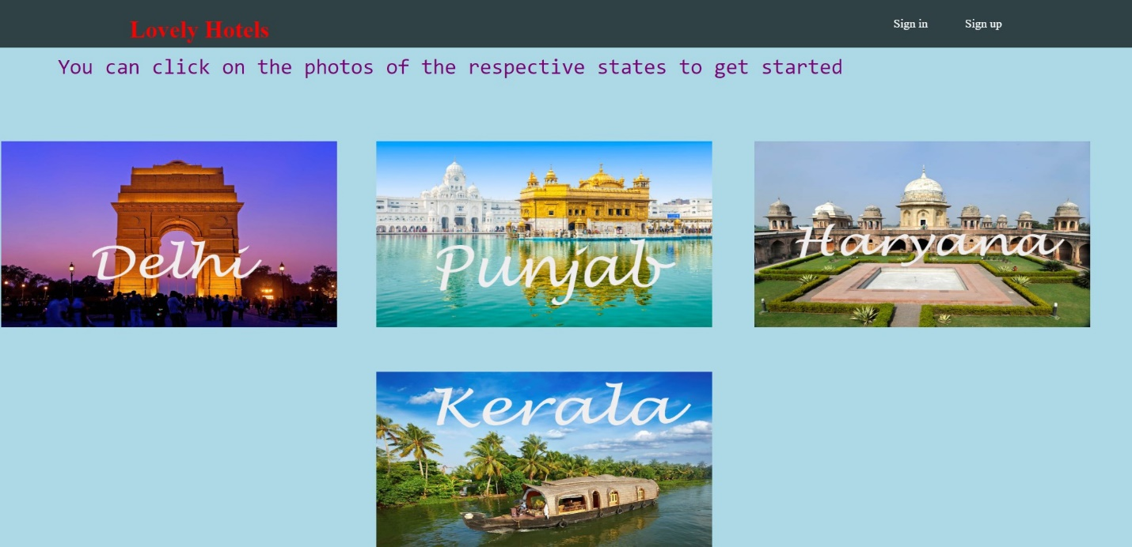

**PLACE WISE HOTEL LISTING**

* Listing of hotel place wise
* Contains hotel image
* “Book” button for continue to book the hotel.

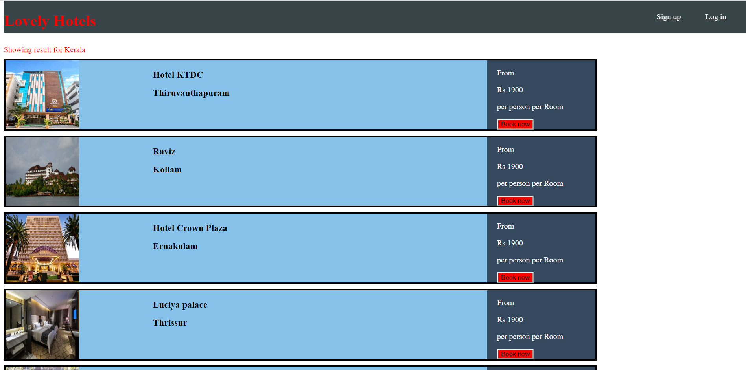

**BOOKING PAGE**

* This page contain form to enter the personal information
* This page contain access to select the type of room and also extra availabilities in hotel to select like selecting pool
* There is a option to select the payment gateway that the customer want to pay to the hotel

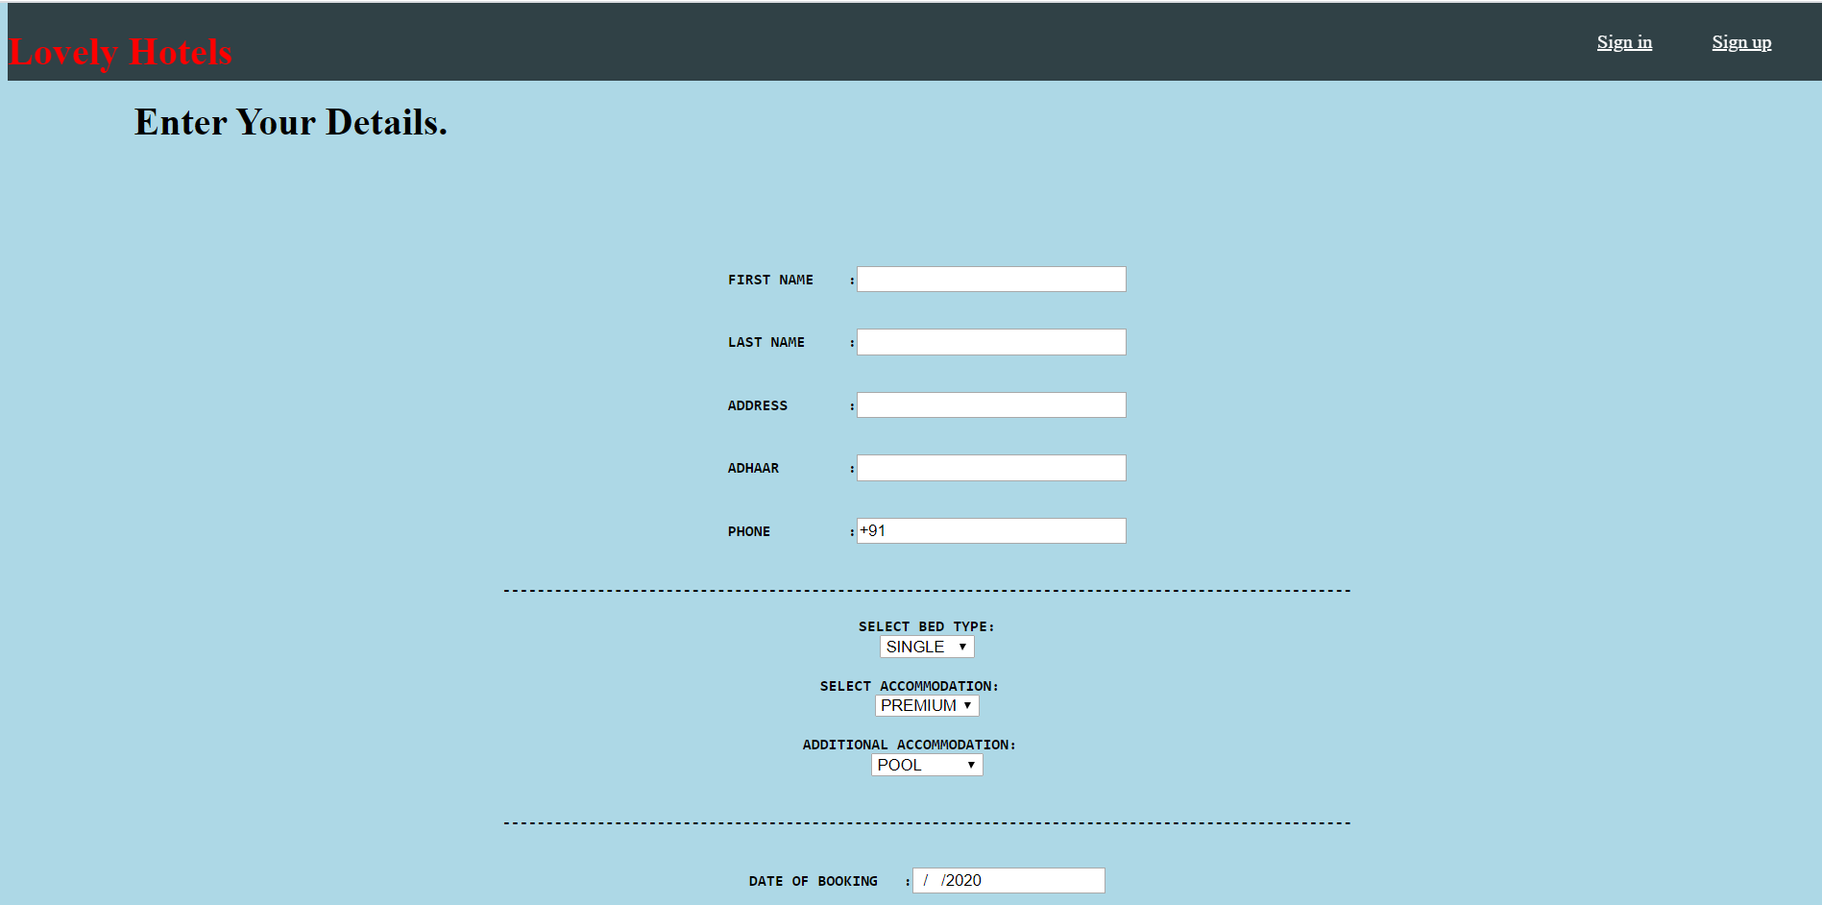

**Advantages:**

* Sometime it happens that the rooms get booked soon when one visits the place, therefore the user can make advance booking using this system.
* It saves user time in searching a room.
* It saves organization resources and expenses.
* This system is effective and saves time and cost of users.

**Disadvantages:**

* The booking process usually requires a customer identity, which the system cannot detect.
* The payment gateway is not Implemented.
* Slow loading of some pages due to size of some online images.